PAPER PENCIL TEST

&

LORENZ CURVE

ASSIGNMENT-01

NAME :S.TAUFIQ AHAMED

REG.NO :121012012771

SUBJECT :**DATA SCIENCE**

CROSE NAME:DATA VISUALIZATION AND TEXT ANALYSIS

BRANCH :B.TECH(**CSE)-2Nd YEAR**

PAPER PENCIL TEST

What is a paper pencil?

Paper-and-pencil instruments refer to a general group of assessment tools in which candidates read questions and respond in writing. This includes tests, such as knowledge and ability tests, and inventories, such as personality and interest inventories.

What is paper and pencil test in education?

Paper-and-pencil assessment refers to traditional student assessment formats such as written tests and also to standardized tests that ask students to use pencils to fill in bubbles on a scannable answer sheet. Item development is a crucial step that determines the validity and reliability of an assessment.

What are the types of paper and pencil tests?

We'll introduce participants to the different types of items in a paper and pencil test: multiple choice, true/false, matching, completion, constructed response, and essay.

What is the weakness of paper and pencil test?

**Disadvantages of the paper-pencil survey**

High costs for printing and possibly dispatch. Large amount of work involved in transcribing the data (especially handwritten free texts) Low response rate (in extreme cases only five per cent)

* **Paper-and-pencil assessment** refers to traditional student assessment formats such as written tests and also to standardized tests that ask students to use pencils to fill in bubbles on a scannable answer sheet.

* Standardized tests are now commonly administered on computers, but classroom assessment usually requires students to submit written responses on paper.
* In the classroom, paper-and-pencil assessment frequently refers to tests scored objectively, which are meant to measure memorized knowledge and lower levels of understanding, as compared with performance-based assessment, which is meant to measure deeper understanding through skills and ability.
* Paper-and-pencil instruments refer to a general group of assessment tools in which candidates read questions and respond in writing. This includes tests, such as knowledge and ability tests, and inventories, such as personality and interest inventories.
* Paper-and-pencil tests can be used to assess job-related knowledge and ability or skill qualifications. The possible range of qualifications which can be assessed using paper-and-pencil tests is quite broad
* Because many candidates can be assessed at the same time with a paper-and-pencil test, such tests are an efficient method of assessment.

LORENZ CURVE

A Lorenz curve is a graphical representation of the distribution of income or wealth within a population. Lorenz curves graph percentiles of the population against cumulative income or wealth of people at or below that percentile.

USE OF THIS LORENZ CURVE

* Lorenz curves graph percentiles of the population against cumulative income or wealth of people at or below that percentile. Lorenz curves, along with their derivative statistics, are widely used to measure inequality across a population.
* Showing distributing of income among the people.
* Helps with comparing two or more factors of production.
* Helps with comprehending the changes in wages and inequality of income.
* In such use, many economists consider it to be a measure of social inequality.

Use of Gini index in data modelling

The Gini Coefficient or Gini Index measures the inequality among the values of a variable. Higher the value of an index, more dispersed is the data. Alternatively, the Gini coefficient can also be calculated as the half of the relative mean absolute difference.

Graphical Representation of the Gini Index (Lorenz curve)

The Gini coefficient is usually defined mathematically based on the Lorenz curve, which plots the proportion of the total income of the population (y-axis) that is cumulatively earned by the bottom x% of the population.

The line at 45 degrees thus represents perfect equality of incomes.

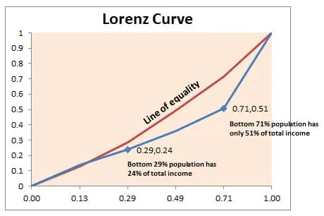

The Gini index is often represented graphically through the Lorenz curve, which shows income (or wealth) distribution by plotting the population percentile by income on the horizontal axis and cumulative income on the vertical axis.

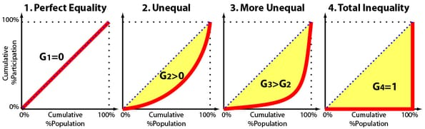Another way of thinking about the Gini coefficient is as a measure of deviation from perfect equality. The further a Lorenz curve deviates from the perfectly equal straight line (which represents a Gini coefficient of 0), the higher the Gini coefficient and the less equal the society.

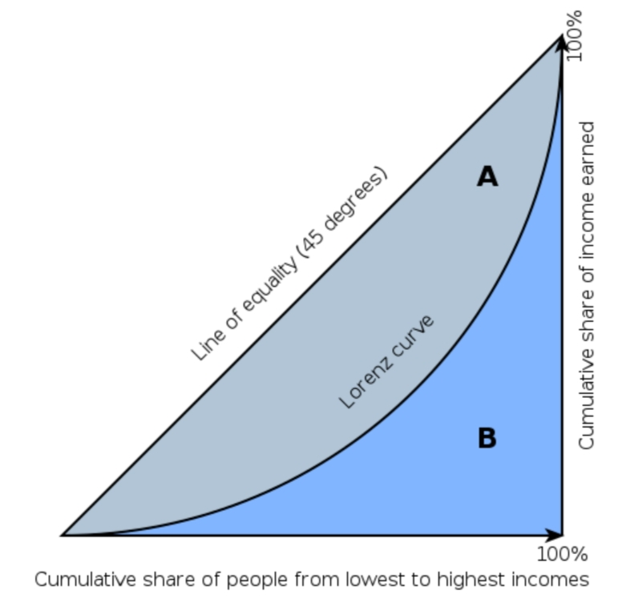

Example:

Following is an excel illustration of how Gini coefficient can be calculated by plotting the Lorenz curve and calculating the area between the equality line and the curve..

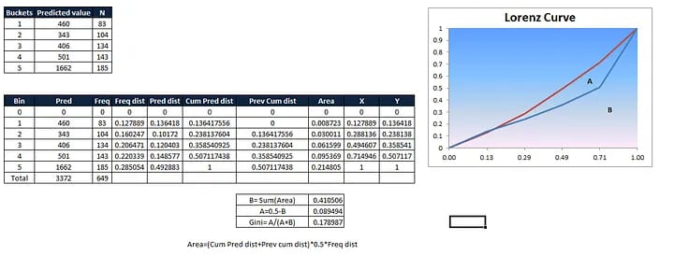

THANK YOU!